Rick Walsh
Making Music: The Manufacturing of Compact Discs
MEEG 453
Bill
11/12/2009

This paper provides a brief overview of the two major manufacturing processes used in the manufacture of Compact Discs: Replication and Duplication. It will also discuss the economics of each method and what applications they are suited for. The paper also describes the makeup of a CD and the relevance of the topic to both experienced and new engineers.

Compact Discs

Introduction
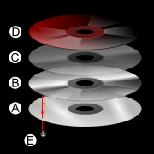
The compact disc is a data storage device originally developed as the successor to the traditional vinyl records used in the music industry. The CD is made up of several layers that are shown below in Figure 1. Layer “A” is made of transparent polycarbonate and is where the data on the disc is stored by a series of “bumps”. Layer B is a reflective layer, often aluminum, which is used to help the CD player read the stored data in the polycarbonate layer. Layer C is a lacquer that is used to protect Layers A and B. Finally D represents the printed labels on a CD.
Figure 1: CD Layers
It is often believed that all CDs are “burned” using a process similar to that performed by a personal computer. That process is referred to as Duplication, and is used in some limited situations. The more prominent manufacturing process uses a stamping and molding procedure called Replication. Each of these methods and their applications are described below.

Duplication
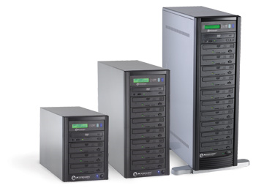
As mentioned before, CD duplication is what occurs when an individual burns a CD on their personal computer. An existing version of the CD must be used. The data is extracted by the PC and lasers inscribe blank CDs to make an exact copy of the original CD. This is done on a larger scale than a normal PC with the help of towers which contain several CD trays. Many of these towers are connected so that they can all create multiply copies of the original simultaneously. Examples of these towers can be seen in Figure 2. The computer then verifies that the data on the copies matches the original and the process is complete.
Figure 2: CD Burning Towers

Replication
Replication is the process that uses a master die and molds CDs in large quantities. This process has several major steps. First a glass plate is used to make a “Master” disc. The glass is cleaned very thoroughly using de-ionized water and a fine bristled brush. Next a layer of photo resistant material (150 microns thick) is applied using a spin coating technique. This is baked at 80 degrees C for about 30 minutes to harden the photoresist layer. A laser then softens certain areas of the layer, which records the desired data to the master. A sodium hydroxide solution is then used to etch the master, in effect “developing” it. It leaves behind pits in the master. This is similar to etching techniques used in creating silicon wafers.
The following step uses a process called electroplating to create a nickel alloy coating of the master disc. The electroplating process utilizes an electric current to reduce cations from a solution and coat a conductive surface with a thin layer of the desired material; in this case the nickel alloy. This layer of electroformed nickel is removed and called the “father” stamp. This is used to make a “mother” (inverse of the father) and subsequently children which are finally used to stamp production CDs. The reason for all of these steps is that if the “father” was used as the stamper it would wear out quickly and since the master is damaged when creating the “father”, the whole developing and electroplating process would have to be performed again, which is expensive and time consuming. By creating additional stampers it removes the need to redo those steps. Now the process can move on to the molding step.


In the molding part of the operation, the metal stamper is used in an injection molding machine to press the pits and lands that make up the data image into injected liquid polycarbonate plastic. The stamping die in the injection molding machine can be seen in Figure 3. The clear disc is then removed and has to be metalized. This involves applying a very thin (0.050.1 micron) layer of aluminum to the polycarbonate. This provides a reflective surface so that the CD machine can read the disc. Next a protective layer is spin-coated on the surface, a process depicted in Figure 4. This layer is 67 microns thick and is made up of acrylic lacquer, which is cured under UV light. This protects the aluminum from the environment and the subsequent labeling process. Adding the label is the final step, and then the disc is ready to be packaged and shipped.
Figure 4: Lacquer Layer Application
Figure 3: Stamping Die

Applications/Economics:
Both of these processes exist to serve different markets. The duplication process is significantly faster than Replication for smaller batch sizes because it has very low set up time, and does not require dedicated equipment. Duplication is usually used for orders up to 1,000 though sometimes as many as 5,000 units. The disadvantage of using this system is that the cost per unit is higher for Duplication than Replication as the number of units increase. Also the process is less automated and therefore more labor intensive. Therefore this method is used for small production runs, or for orders that need to be filled immediately.
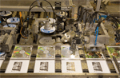
In contrast, Replication (see Figure 6) is significantly more automated and use much more dedicated equipment. Most replication facilities are almost 100% automated and therefore can manufacture as many as 100,000 CDs a day. But since the dies are specific to a certain CD there is a large changeover time, as well as a larger cost included in creating the master die. But for larger runs it is more cost effective to use this type of machinery and process. Also due to the large amount of automation packaging is often significantly faster and cheaper for replication facilities (See figure 5). There are also some additional features that be added to a DVD using replication not available in duplication, but that is not within the scope of this paper.
Figure 5: Automated CD handling/packaging
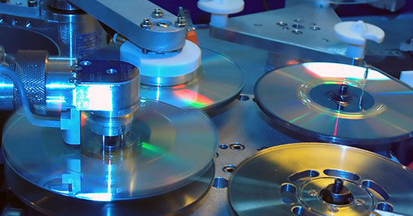

Figure 6: Several steps in the Replication process

Relevance for Engineers:

Beginning Engineer:
The significance of this topic for the beginning engineer is that it is a classic example of quantity versus variety tradeoff. Much like machining and injection molding, each of the two methods are ideal in a certain quantity range. As the number of units increases the move towards more automation is needed which sacrifices on flexibility. This is a direct application of that principle, and a young engineer should recognize that. Also the complexity of the Replication process should be appreciated by a new engineer. Recognition of ME fundamentals and manufacturing topics such as material handling should be recognized by the new engineer as well.

Experienced Engineer:
The significance of this topic for the experienced engineer is to see all the engineering fundamentals being used in the process. Fluids, heat transfer, and materials are all very evident in the Replication process. Due to the incorporation of robotics, electronics, chemicals and manufacturing a team of engineers of different disciplines should be used to ensure a quality product. They should also be aware of quantity versus variety tradeoff that is occurring. In addition the experienced engineer should recognize some of the similarities with other processes such as silicon etching among others and realize that these are concepts that could be applied as manufacturing solutions in other areas as well.

Learning
During the course of this assignment I learned about the two main methods for manufacturing Compact Discs: Replication and Duplication. I was not familiar with the application of the quantity versus variety principle to manufacturing CDs. I also learned that etching techniques, coating applications, and other ME fundamentals are used extensively in the process of making CDs. I also came to appreciate the complexity and expense that goes in the replication process, as well as the range of expertise needed to create such a process. Overall this was a very educational assignment.

Works Cited
"CD Manufacture -." The Classical Recording Company. Web. 11 Nov. 2009. <http://www.classicalrecording.co.uk/html/cd_manufacture.htm>.
"Compact Disc." Compact Disc. Wikipedia. Web. 11 Nov. 2009. <http://en.wikipedia.org/wiki/Compact_Disc#History>.
Digital image. Amstore Group. Web. 11 Nov. 2009. <http://www.hotfrog.co.za/Uploads/PressReleases/CD-DVD-Replication-Duplication-Full-Packaging-5196_image.jpg>.
Disc Works. Web. 11 Nov. 2009. <http://discworks.com/services?service=CD+Replication>.
"Duplication versus Replication for CD and DVD: What's the Difference? - Advanced Digital Replication, Inc." Home - Advanced Digital Replication, Inc. Web. 11 Nov. 2009. <http://www.mediareplication.com/index.php?option=com_content&task=view&id=35&Itemid=48>.
"How Are CDs Manufactured? | eHow.com." EHow | How To Do Just About Everything! | How To Videos & Articles. Web. 12 Nov. 2009. <http://www.ehow.com/how-does_4909642_how-cds-manufactured.html>.
How It's Made: CD & DVD. Web. 11 Nov. 2009. <http://www.youtube.com/watch?v=YZKD2aYLTWw>.
"Manufacturing process for data CD ROM and audio CD." Submit articles to the directory. Article submission is free! Web. 11 Nov. 2009. <http://e-articles.info/e/a/title/Manufacturing-process-for-data-CD-ROM-and-audio-CD/>.

